**Dynamic Array:**

In Solidity, if you want an array whose size can change dynamically during execution, you should use a data structure called a "dynamic array" or "dynamic-sized array." In Solidity, this is commonly achieved using the **push** method on a storage array.

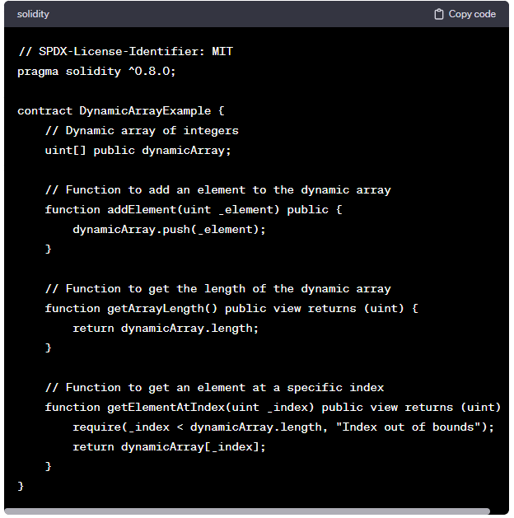

Remember that dynamic arrays in Solidity can be more gas-expensive compared to fixed-size arrays, so you should consider the gas cost when using dynamic arrays, especially in scenarios where gas efficiency is crucial.

**Code:**

//SPDX-License-Identifier: GPL-3.0

pragma solidity ^0.8.0;

contract DynamicSizeArray{

    uint[] public arr;

    function pushelement(uint item) public

    {

        arr.push(item);

    }

    function len() public view returns(uint)

    {

        return arr.length;

    }

    function popelement() public

    {

        arr.pop();

    }

}

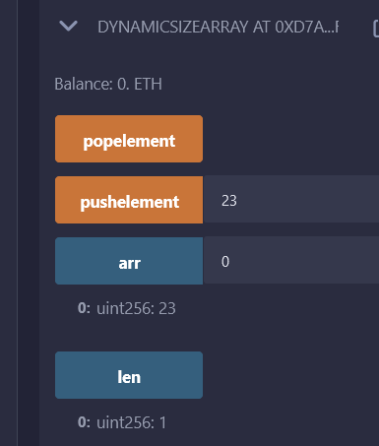

//SPDX-License-Identifier: GPL-3.0

pragma solidity ^0.8.0;

contract DynamicSizeArray {

    uint[] public arr = [10,299,323,545,32,43,1];

    function returnArray() public view returns(uint[] memory){

        return arr;

    }

}

